Cavalier Projection
# Source: AI Source: Provided by: [Data Path: Persons Table -> ID Column: 1, Name_En Column: Motasem Essam] -> From: [ChatGPT] on [7/25/2026]
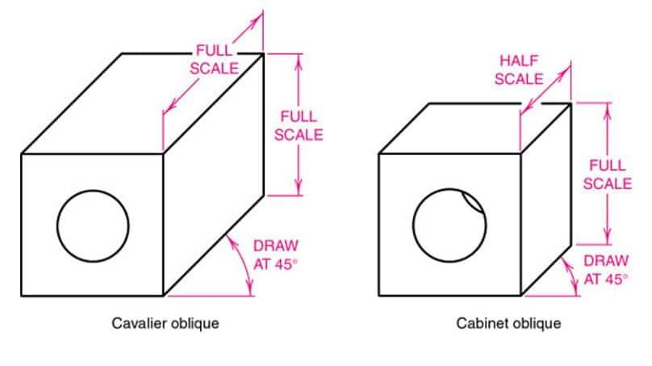
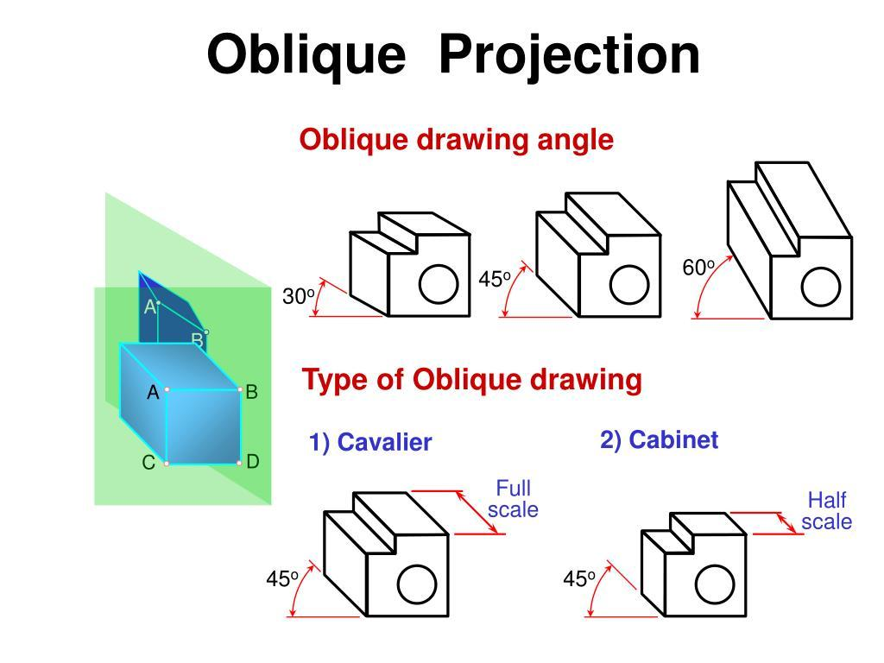
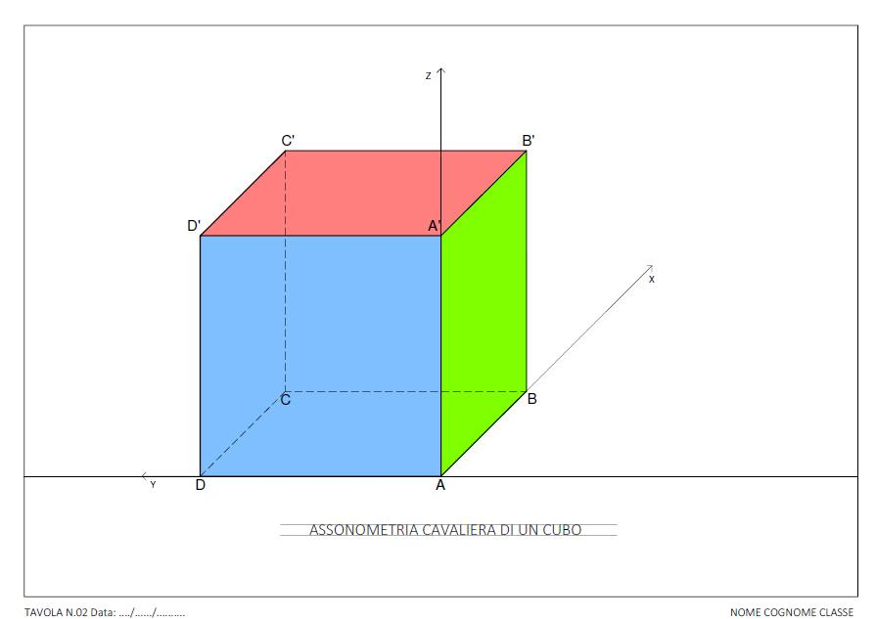
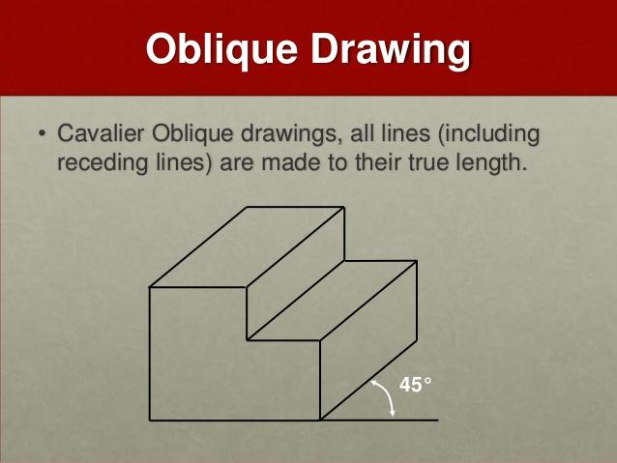
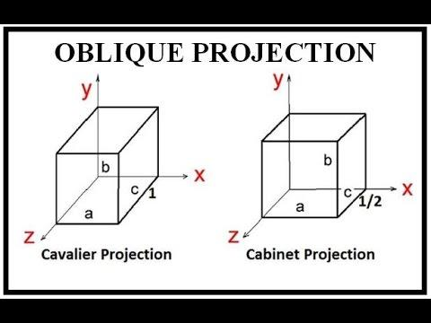
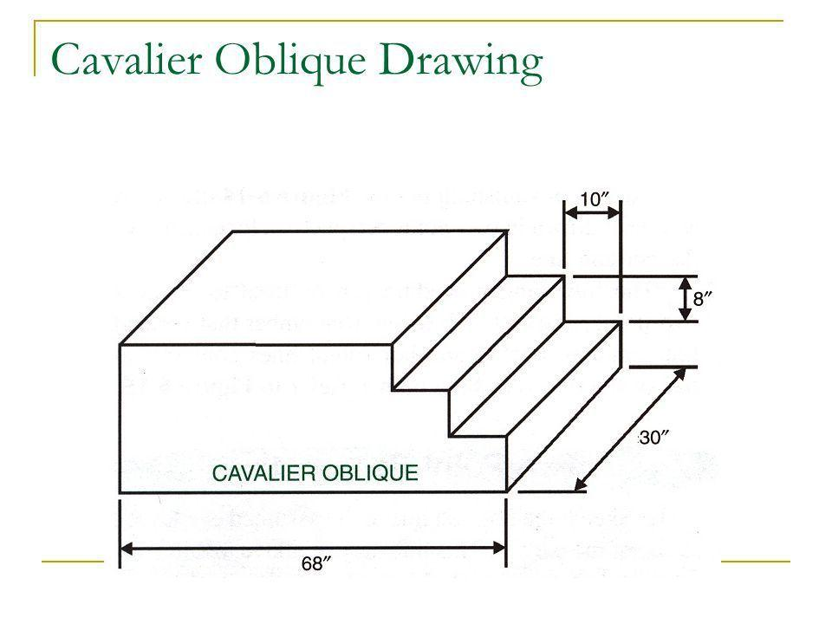

Definition
# Source: AI Source: Provided by: [Data Path: Persons Table -> ID Column: 1, Name_En Column: Motasem Essam] -> From: [ChatGPT] on [7/25/2026]
Cavalier Projection is a type of oblique parallel projection in which an object is projected onto a plane using parallel projection lines, while the lines representing depth are usually drawn at their true length.
In other words, a three-dimensional object is represented on a two-dimensional plane, and:
- Projection lines are parallel.
- Projection lines are not perpendicular to the projection plane.
- The depth dimension is drawn at full scale.
- The front face of the object is usually represented in its true shape and size.

Main idea
# Source: AI Source: Provided by: [Data Path: Persons Table -> ID Column: 1, Name_En Column: Motasem Essam] -> From: [ChatGPT] on [7/25/2026]
If a point $P$ is projected onto a plane along direction $d$:
$$P^{'}=P+td$$
where:
- $P$ = original point
- $P^{'}$ = projected point
- $d$ = projection direction
- $t$ = scalar
For Cavalier projection, the projection direction is oblique to the projection plane.

Purpose
# Source: AI Source: Provided by: [Data Path: Persons Table -> ID Column: 1, Name_En Column: Motasem Essam] -> From: [ChatGPT] on [7/25/2026]
Cavalier projection is used to:
- Represent 3D objects on 2D surfaces.
- Show the front face accurately.
- Represent depth without using perspective.
- Create technical and engineering drawings.
- Illustrate geometric solids.
- Make simple 3D diagrams.
- Preserve the true length of depth lines.

Basic Configuration
# Source: AI Source: Provided by: [Data Path: Persons Table -> ID Column: 1, Name_En Column: Motasem Essam] -> From: [ChatGPT] on [7/25/2026]
Suppose a rectangular box has front vertices:
$$A, B, C, D$$
and corresponding back vertices:
$$A^{'}, B^{'}, C^{'}, D^{'}$$
The depth edges are drawn in the same direction:
$$AA^{'}∥BB^{'}∥CC^{'}∥DD^{'}$$
In Cavalier projection, these depth edges are drawn at their actual length.

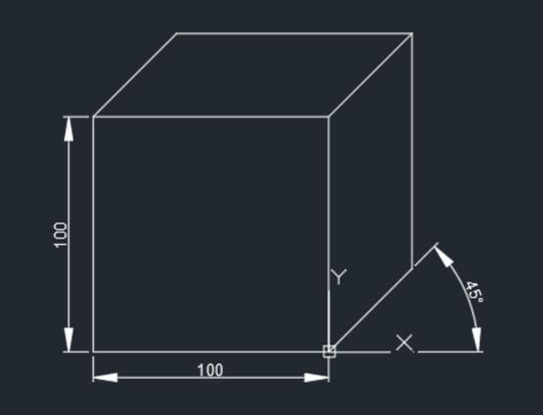
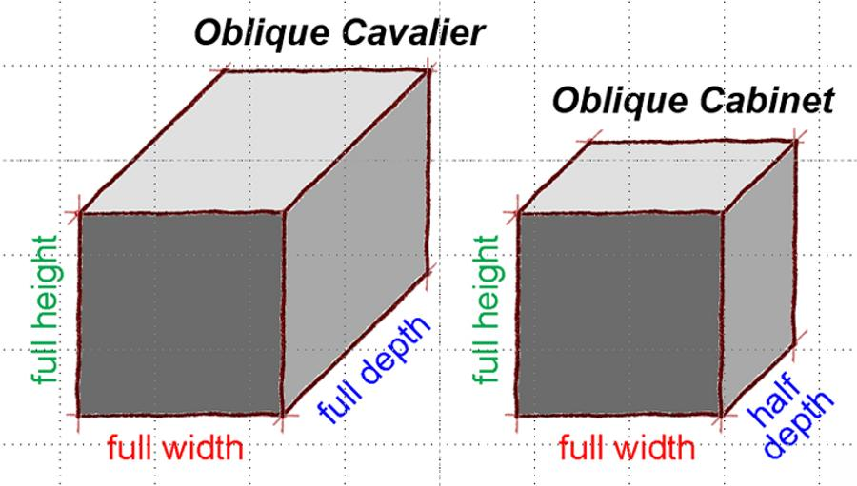
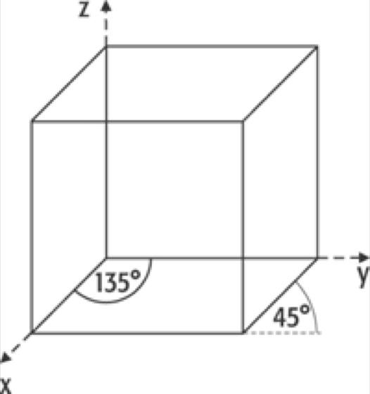
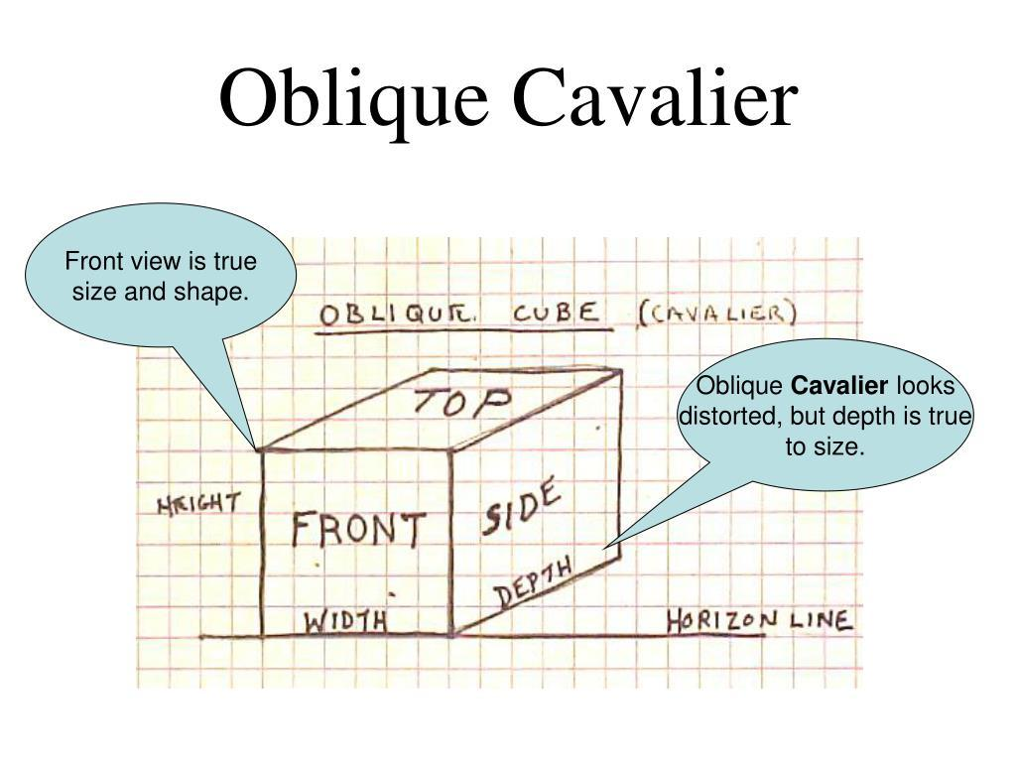

Fundamental Elements

1. Projection Plane
# Source: AI Source: Provided by: [Data Path: Persons Table -> ID Column: 1, Name_En Column: Motasem Essam] -> From: [ChatGPT] on [7/25/2026]
The two-dimensional plane onto which the 3D object is projected.
It can be represented as:
$$Π$$

2. Original Object
# Source: AI Source: Provided by: [Data Path: Persons Table -> ID Column: 1, Name_En Column: Motasem Essam] -> From: [ChatGPT] on [7/25/2026]
The three-dimensional object being represented.
Examples:
- Cube
- Rectangular prism
- Cylinder
- Pyramid

3. Projection Direction
# Source: AI Source: Provided by: [Data Path: Persons Table -> ID Column: 1, Name_En Column: Motasem Essam] -> From: [ChatGPT] on [7/25/2026]
The direction in which the projection lines travel.
$$d$$
The projection direction is not perpendicular to the projection plane.

4. Projection Lines
# Source: AI Source: Provided by: [Data Path: Persons Table -> ID Column: 1, Name_En Column: Motasem Essam] -> From: [ChatGPT] on [7/25/2026]
All projection lines are parallel:
$$AA^{'}∥BB^{'}∥CC^{'}$$

5. Projected Object
# Source: AI Source: Provided by: [Data Path: Persons Table -> ID Column: 1, Name_En Column: Motasem Essam] -> From: [ChatGPT] on [7/25/2026]
The resulting 2D representation of the original 3D object.

Characteristics of Cavalier Projection
# Source: AI Source: Provided by: [Data Path: Persons Table -> ID Column: 1, Name_En Column: Motasem Essam] -> From: [ChatGPT] on [7/25/2026]
The most important characteristics are:
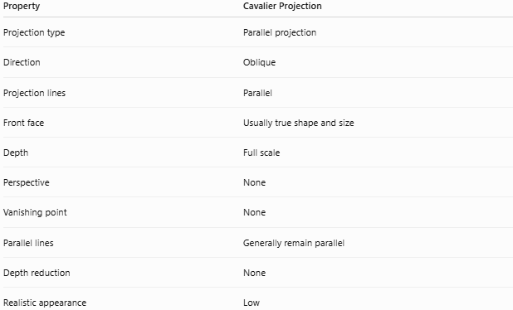
Property | Cavalier Projection
Projection type | Parallel projection
Direction | Oblique
Projection lines | Parallel
Front face | Usually true shape and size
Depth | Full scale
Perspective | None
Vanishing point | None
Parallel lines | Generally remain parallel
Depth reduction | None
Realistic appearance | Low

Depth Dimension
# Source: AI Source: Provided by: [Data Path: Persons Table -> ID Column: 1, Name_En Column: Motasem Essam] -> From: [ChatGPT] on [7/25/2026]
The defining characteristic of Cavalier projection is that depth is represented at full scale.
Suppose a box has:
- Width = $6$
- Height = $4$
- Depth = $3$
Then the depth edges in a Cavalier drawing are represented as:
$$3$$
rather than being reduced.
So:
$$\boxed{\text{Drawn depth}=\text{Actual depth}}$$
This is different from Cabinet Projection, where depth is commonly reduced to one-half.

Projection Angle
# Source: AI Source: Provided by: [Data Path: Persons Table -> ID Column: 1, Name_En Column: Motasem Essam] -> From: [ChatGPT] on [7/25/2026]
The receding/depth lines are commonly drawn at an angle such as:
$${45}^{∘}$$
to the horizontal or vertical reference direction.
For example:
$$\boxed{θ={45}^{∘}}$$
is a common choice, although Cavalier projection is defined primarily by full-depth representation and oblique parallel projection, not by one mandatory angle.

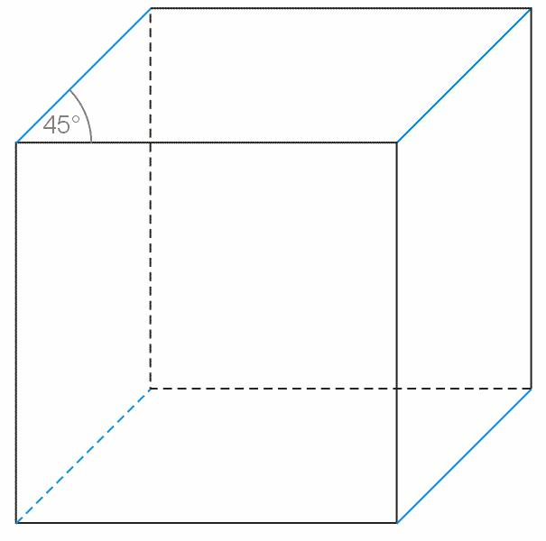
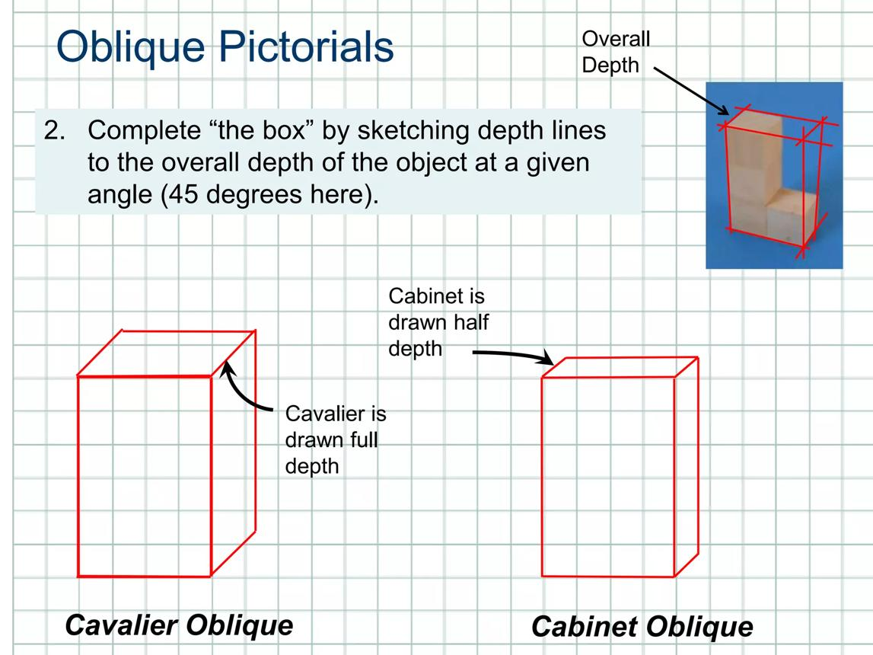
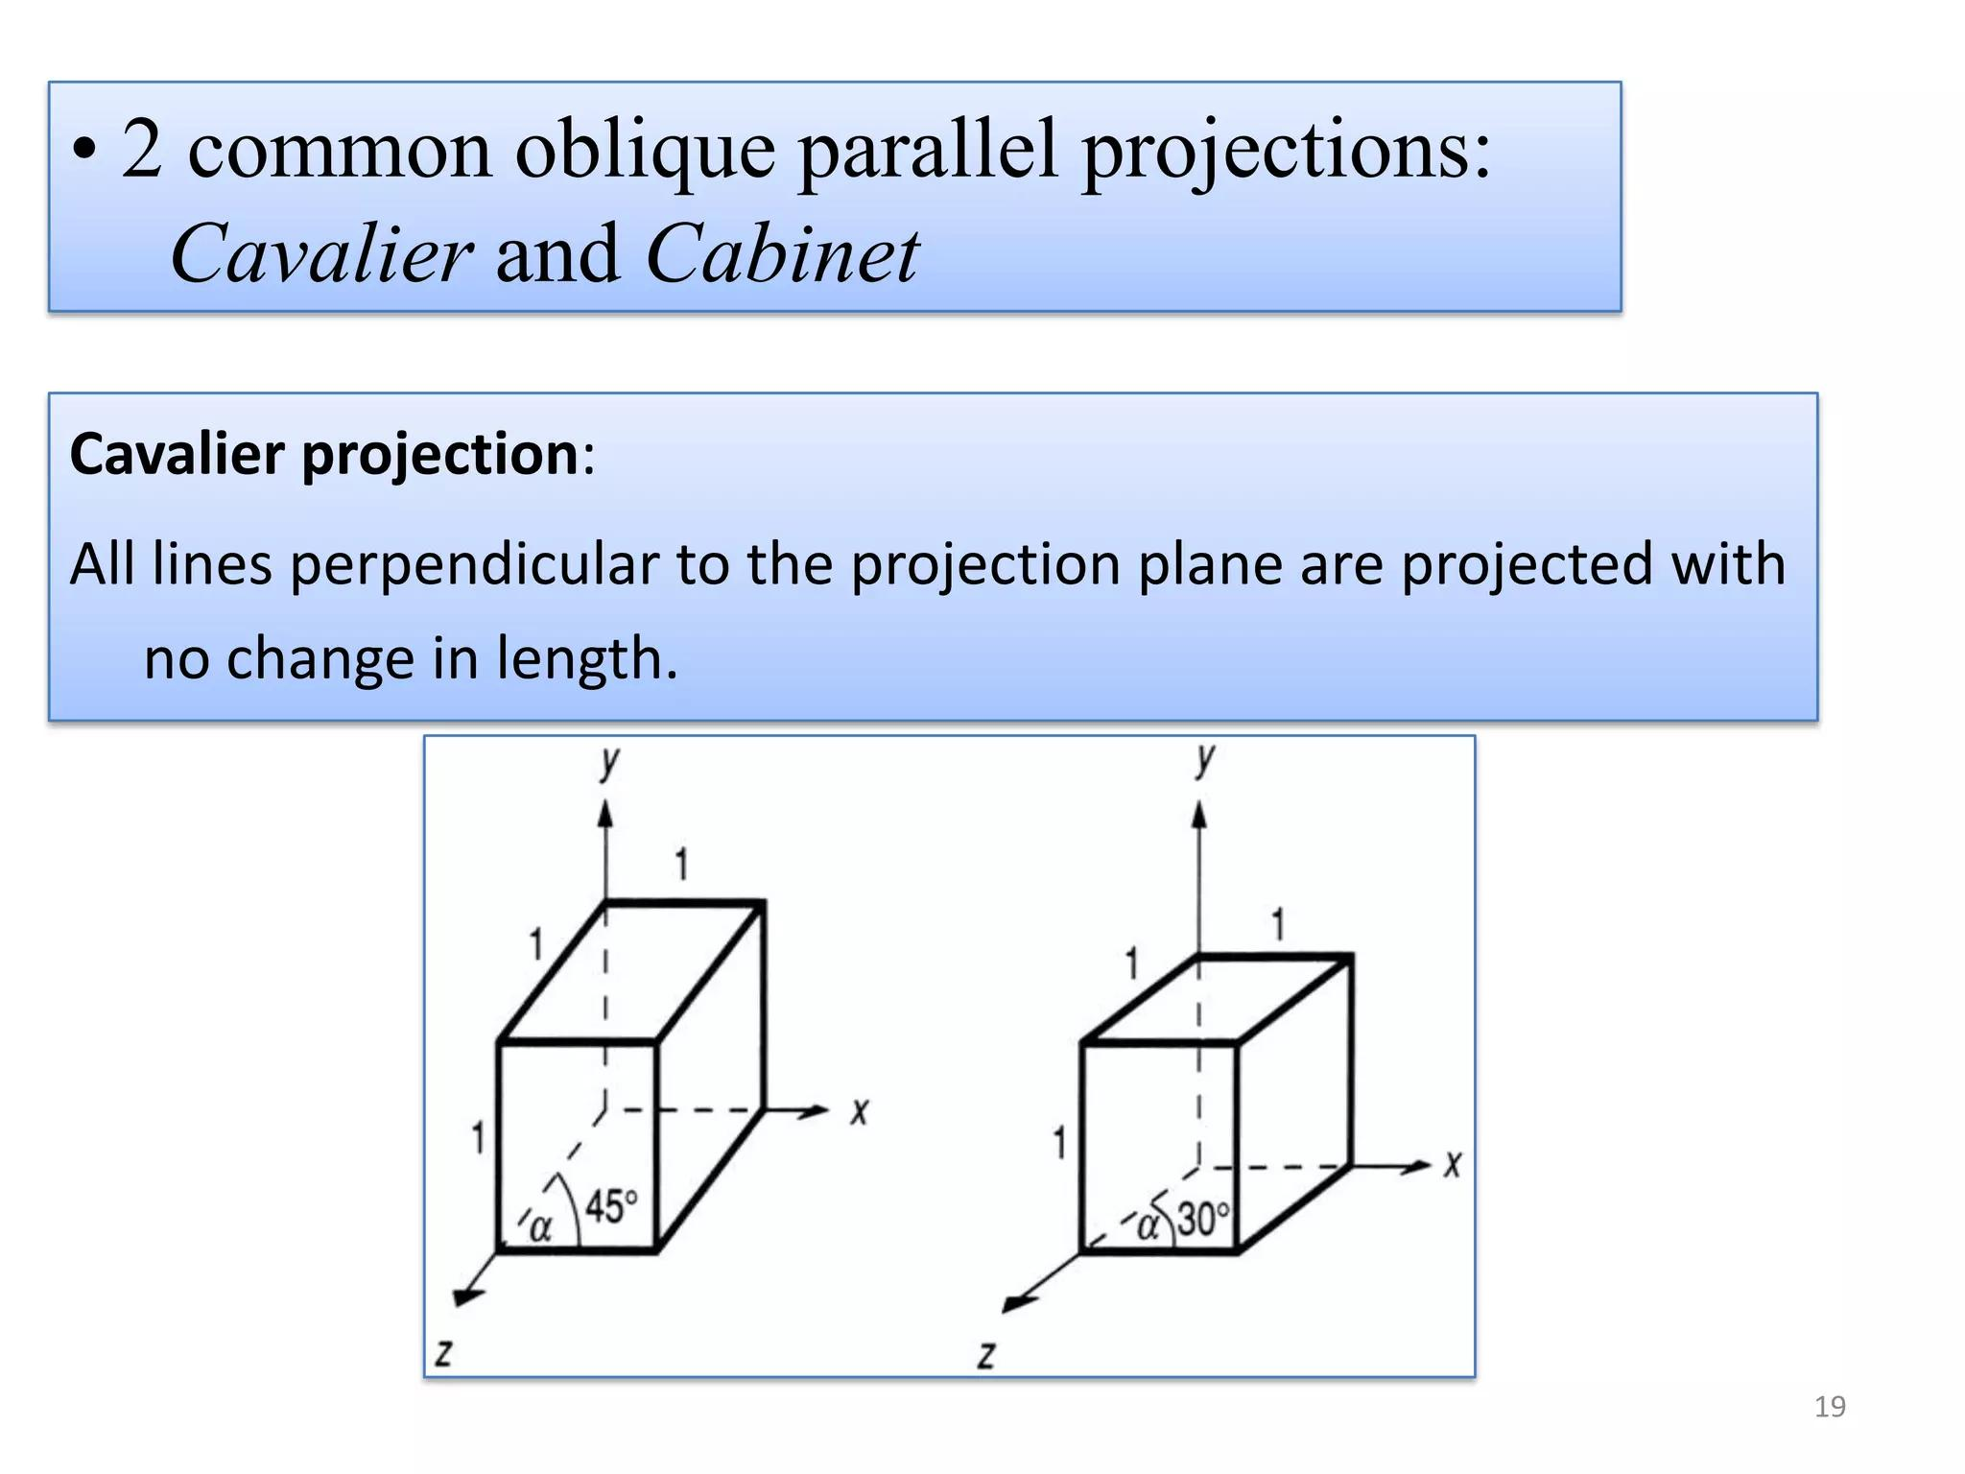

Mathematical Representation
# Source: AI Source: Provided by: [Data Path: Persons Table -> ID Column: 1, Name_En Column: Motasem Essam] -> From: [ChatGPT] on [7/25/2026]
For a general parallel projection:
$$P^{'}=P+td$$
where $P^{'}$ lies on the projection plane.
If the projection plane is:
$$z=0$$
and:
$$P=(x,y,z)$$
with projection direction:
$$d=(d_{x},d_{y},d_{z})$$
then:
$$P^{'}=P+td$$
The value of $t$ is selected so that:
$$z+td_{z}=0$$
Therefore:
$$t=-\frac{z}{d_{z}}$$
and:
$$\boxed{P^{'}=\left(x-\frac{zd_{x}}{d_{z}},y-\frac{zd_{y}}{d_{z}},0\right)}$$
This describes the mathematical projection; the Cavalier convention additionally specifies that depth is represented at full scale in the drawing.

Example 1: Rectangular Box
# Source: AI Source: Provided by: [Data Path: Persons Table -> ID Column: 1, Name_En Column: Motasem Essam] -> From: [ChatGPT] on [7/25/2026]
Suppose a rectangular box has:
$W=6$ $H=4$ $D=3$
In Cavalier projection:
- Width is drawn as $6$.
- Height is drawn as $4$.
- Depth is drawn as $3$.
Thus:
$\boxed{W^{'}=6}$ $\boxed{H^{'}=4}$ $\boxed{D^{'}=3}$
The depth edges are then drawn obliquely, commonly at ${45}^{∘}$.

Example 2: Depth Line
# Source: AI Source: Provided by: [Data Path: Persons Table -> ID Column: 1, Name_En Column: Motasem Essam] -> From: [ChatGPT] on [7/25/2026]
Suppose an actual depth edge has length:
$$AB=5\text{ cm}$$
In Cavalier projection:
$$A^{'}B^{'}=5\text{ cm}$$
Therefore:
$$\boxed{A^{'}B^{'}=AB}$$
The line changes direction, but its represented depth length remains full scale.

Example 3: Comparing Cavalier and Cabinet Projection
# Source: AI Source: Provided by: [Data Path: Persons Table -> ID Column: 1, Name_En Column: Motasem Essam] -> From: [ChatGPT] on [7/25/2026]
Suppose the actual depth is:
$$D=8\text{ cm}$$
Cavalier
Full depth:
$$D^{'}=8\text{ cm}$$
Cabinet
Commonly half depth:
$$D^{'}=\frac{8}{2}=4\text{ cm}$$
Therefore:
$\boxed{\text{Cavalier: }8\text{ cm}}$
$$\boxed{\text{Cabinet: }4\text{ cm}}$$

How to Construct a Cavalier Projection
# Source: AI Source: Provided by: [Data Path: Persons Table -> ID Column: 1, Name_En Column: Motasem Essam] -> From: [ChatGPT] on [7/25/2026]
A simple Cavalier drawing can be constructed as follows:

Step 1 — Draw the front face
# Source: AI Source: Provided by: [Data Path: Persons Table -> ID Column: 1, Name_En Column: Motasem Essam] -> From: [ChatGPT] on [7/25/2026]
Draw the front face in its true shape and size.
For example, draw a rectangle:
$$6×4$$

Step 2 — Choose the depth direction
# Source: AI Source: Provided by: [Data Path: Persons Table -> ID Column: 1, Name_En Column: Motasem Essam] -> From: [ChatGPT] on [7/25/2026]
Choose an oblique direction, commonly:
$${45}^{∘}$$

Step 3 — Draw depth lines
# Source: AI Source: Provided by: [Data Path: Persons Table -> ID Column: 1, Name_En Column: Motasem Essam] -> From: [ChatGPT] on [7/25/2026]
From each appropriate vertex, draw parallel lines in the chosen direction.

Step 4 — Use the actual depth
# Source: AI Source: Provided by: [Data Path: Persons Table -> ID Column: 1, Name_En Column: Motasem Essam] -> From: [ChatGPT] on [7/25/2026]
If the depth is $3$ units, each depth edge is drawn as $3$ units.

Step 5 — Connect corresponding vertices
# Source: AI Source: Provided by: [Data Path: Persons Table -> ID Column: 1, Name_En Column: Motasem Essam] -> From: [ChatGPT] on [7/25/2026]
Connect the endpoints of the depth lines.
The result is a Cavalier representation of the object.

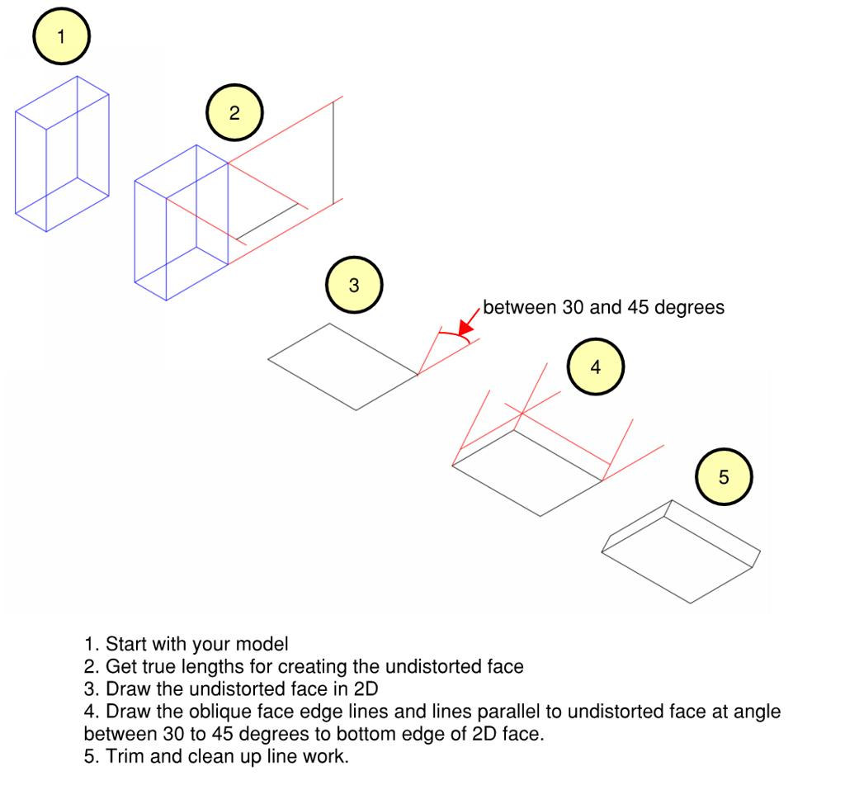
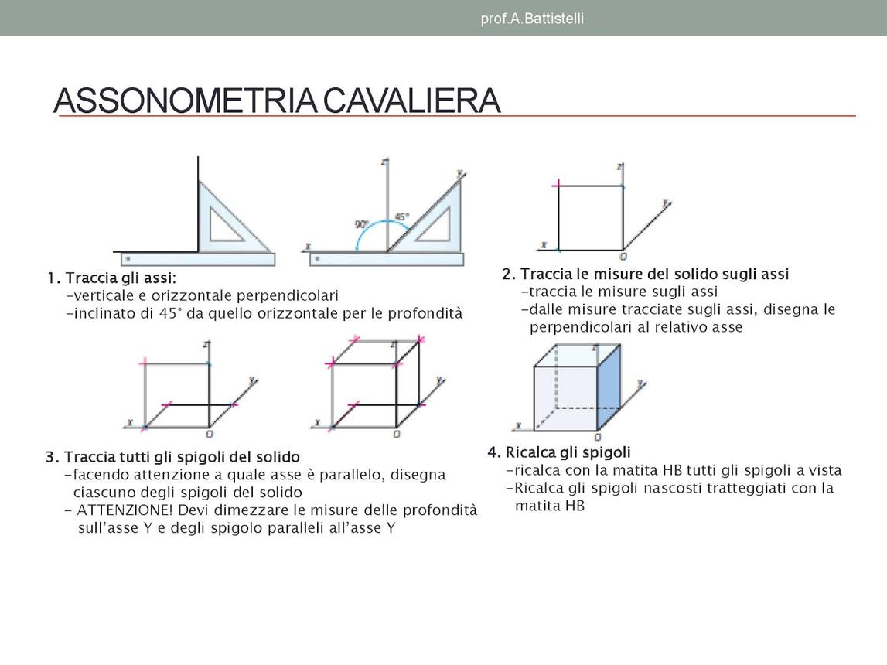
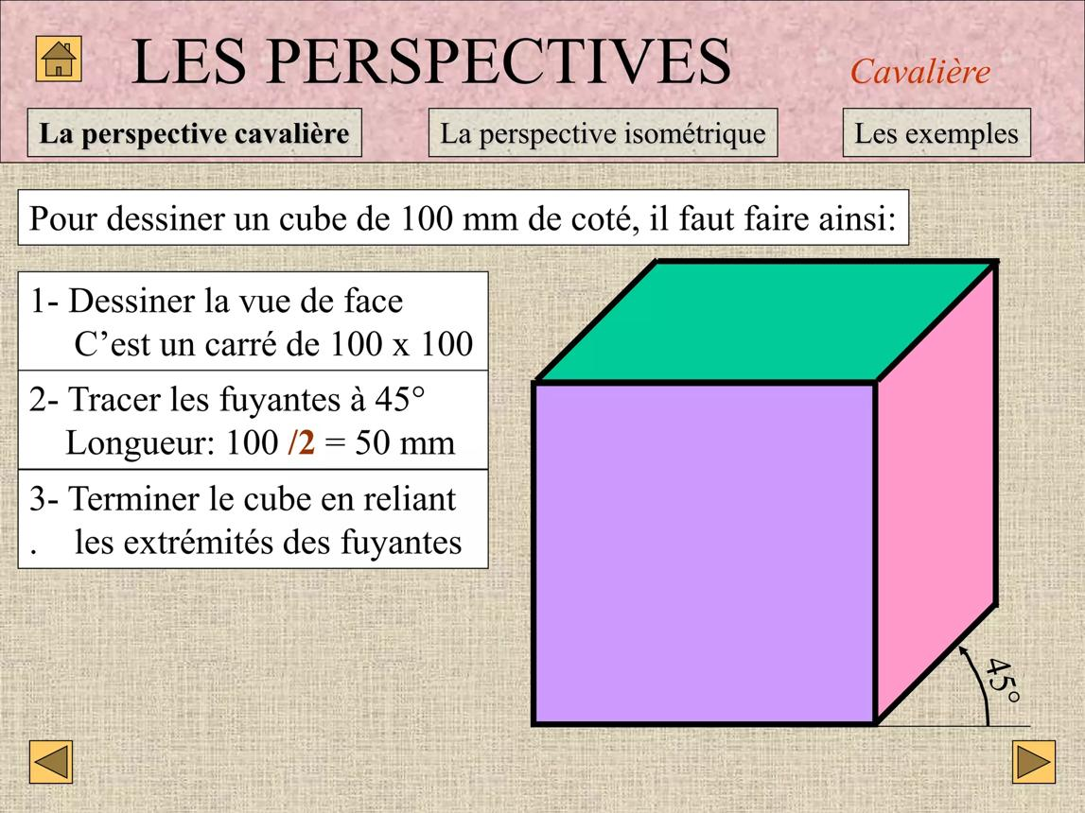
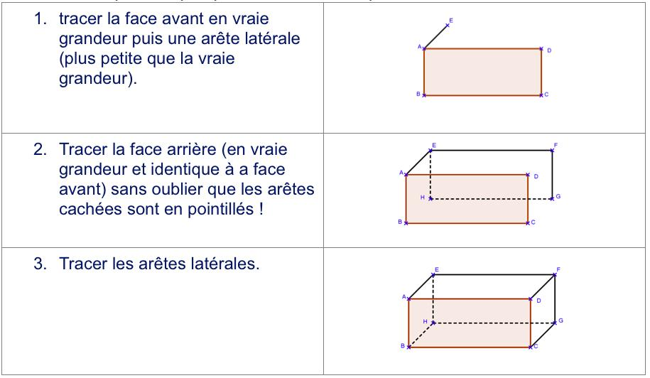
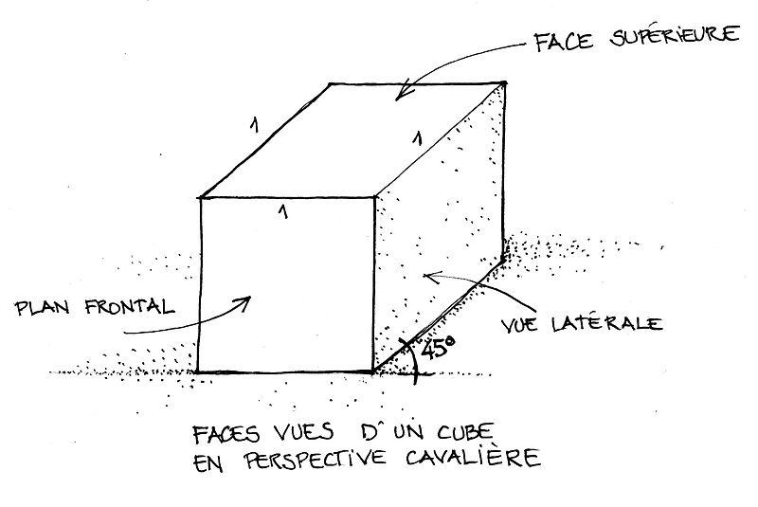

Properties

1. Projection lines are parallel
# Source: AI Source: Provided by: [Data Path: Persons Table -> ID Column: 1, Name_En Column: Motasem Essam] -> From: [ChatGPT] on [7/25/2026]
$$AA^{'}∥BB^{'}∥CC^{'}$$

2. Depth is full scale
# Source: AI Source: Provided by: [Data Path: Persons Table -> ID Column: 1, Name_En Column: Motasem Essam] -> From: [ChatGPT] on [7/25/2026]
$$D^{'}=D$$

3. No vanishing point
# Source: AI Source: Provided by: [Data Path: Persons Table -> ID Column: 1, Name_En Column: Motasem Essam] -> From: [ChatGPT] on [7/25/2026]
Unlike perspective projection, parallel lines do not converge.

4. Front face can retain true dimensions
# Source: AI Source: Provided by: [Data Path: Persons Table -> ID Column: 1, Name_En Column: Motasem Essam] -> From: [ChatGPT] on [7/25/2026]
The front face can be represented without distortion.

5. Parallelism is preserved
# Source: AI Source: Provided by: [Data Path: Persons Table -> ID Column: 1, Name_En Column: Motasem Essam] -> From: [ChatGPT] on [7/25/2026]
Parallel lines in the object generally remain parallel in the projection.

6. Angles are not generally preserved
# Source: AI Source: Provided by: [Data Path: Persons Table -> ID Column: 1, Name_En Column: Motasem Essam] -> From: [ChatGPT] on [7/25/2026]
Although the front face can retain its angles, oblique depth lines can change the apparent angles.

7. Realistic depth is not preserved
# Source: AI Source: Provided by: [Data Path: Persons Table -> ID Column: 1, Name_En Column: Motasem Essam] -> From: [ChatGPT] on [7/25/2026]
The drawing can look exaggerated because depth is shown at full scale.

Cavalier Projection of a Cube
# Source: AI Source: Provided by: [Data Path: Persons Table -> ID Column: 1, Name_En Column: Motasem Essam] -> From: [ChatGPT] on [7/25/2026]
For a cube with side length:
$$a$$
the front face can be drawn as a square with:
$$a×a$$
The depth edges are also drawn with:
$$a$$
Therefore all three dimensions are represented at full scale:
$\boxed{W^{'}=H^{'}=D^{'}=a}$
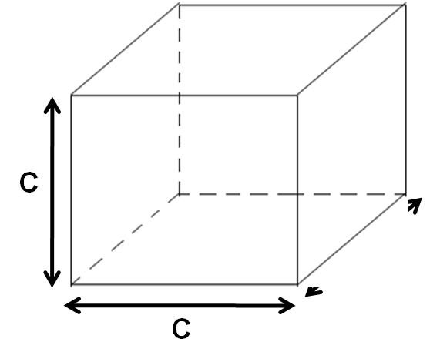
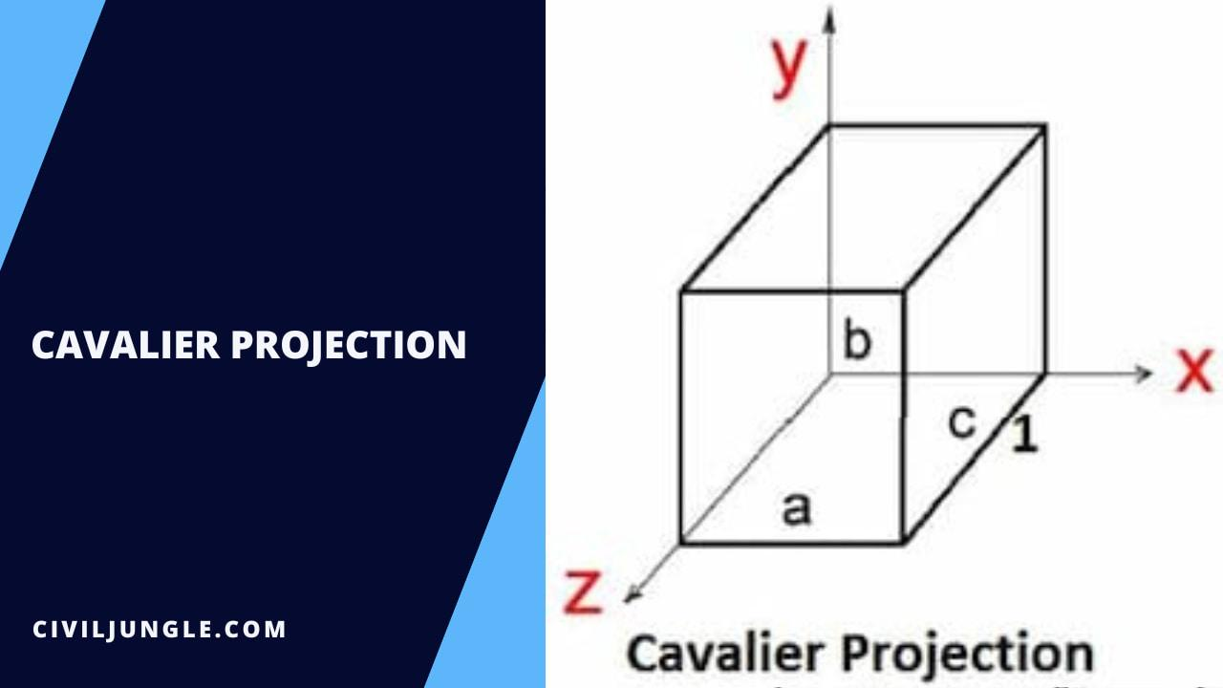
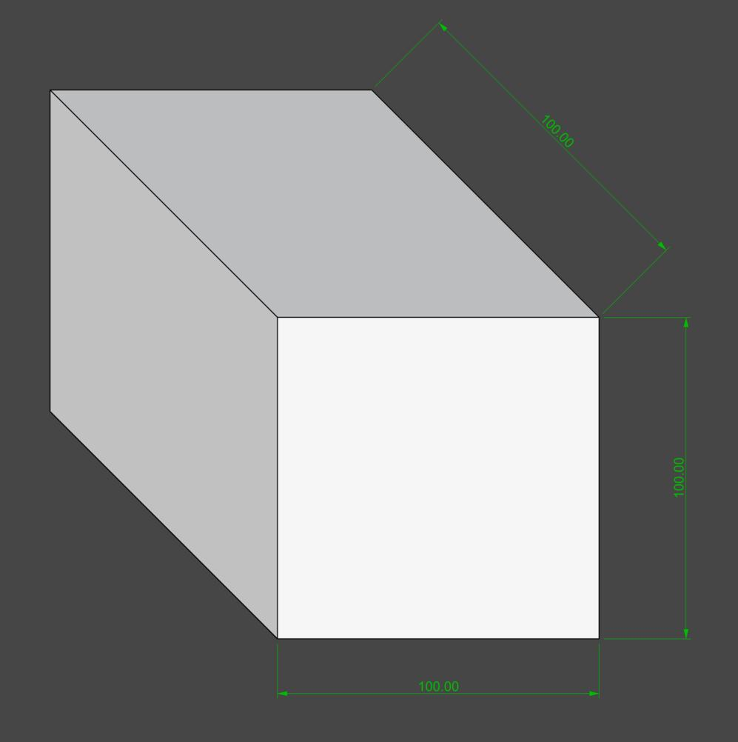
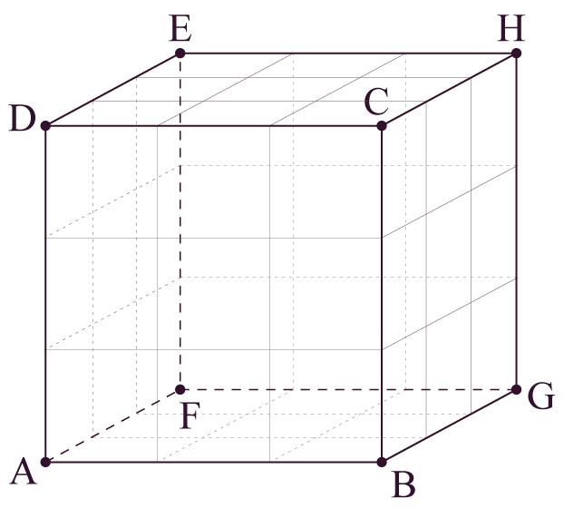

Cavalier Projection vs Cabinet Projection
# Source: AI Source: Provided by: [Data Path: Persons Table -> ID Column: 1, Name_En Column: Motasem Essam] -> From: [ChatGPT] on [7/25/2026]
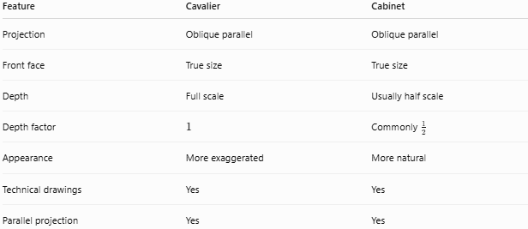
Feature | Cavalier | Cabinet
Projection | Oblique parallel | Oblique parallel
Front face | True size | True size
Depth | Full scale | Usually half scale
Depth factor | $$1$$ | Commonly $\frac{1}{2}$
Appearance | More exaggerated | More natural
Technical drawings | Yes | Yes
Parallel projection | Yes | Yes
The key difference is:
$\boxed{\text{Cavalier: full depth}}$ $\boxed{\text{Cabinet: reduced depth}}$

Cavalier Projection vs Orthogonal Projection
# Source: AI Source: Provided by: [Data Path: Persons Table -> ID Column: 1, Name_En Column: Motasem Essam] -> From: [ChatGPT] on [7/25/2026]
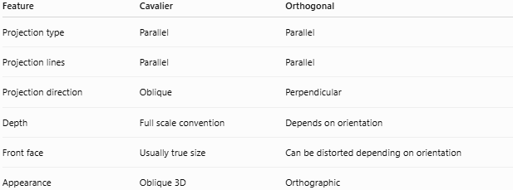
Feature | Cavalier | Orthogonal
Projection type | Parallel | Parallel
Projection lines | Parallel | Parallel
Projection direction | Oblique | Perpendicular
Depth | Full scale convention | Depends on orientation
Front face | Usually true size | Can be distorted depending on orientation
Appearance | Oblique 3D | Orthographic
The defining distinction is:
$$\boxed{\text{Cavalier: }d⟂̸Π}$$
while:
$$\boxed{\text{Orthogonal: }d⟂Π}$$

Cavalier Projection vs Perspective Projection
# Source: AI Source: Provided by: [Data Path: Persons Table -> ID Column: 1, Name_En Column: Motasem Essam] -> From: [ChatGPT] on [7/25/2026]
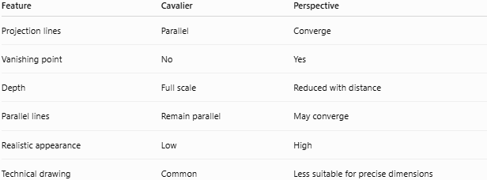
Feature | Cavalier | Perspective
Projection lines | Parallel | Converge
Vanishing point | No | Yes
Depth | Full scale | Reduced with distance
Parallel lines | Remain parallel | May converge
Realistic appearance | Low | High
Technical drawing | Common | Less suitable for precise dimensions

Relationship to Parallel Projection
# Source: AI Source: Provided by: [Data Path: Persons Table -> ID Column: 1, Name_En Column: Motasem Essam] -> From: [ChatGPT] on [7/25/2026]
The hierarchy is:
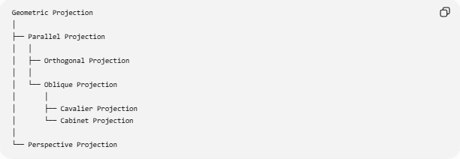
Geometric Projection
│
├── Parallel Projection
│ │
│ ├── Orthogonal Projection
│ │
│ └── Oblique Projection
│ │
│ ├── Cavalier Projection
│ └── Cabinet Projection
│
└── Perspective Projection
Therefore:
$$\boxed{\text{Cavalier Projection}⊂\text{Oblique Projection}⊂\text{Parallel Projection}}$$

Applications
# Source: AI Source: Provided by: [Data Path: Persons Table -> ID Column: 1, Name_En Column: Motasem Essam] -> From: [ChatGPT] on [7/25/2026]
Cavalier projection can be used in:
- Technical illustrations
- Engineering diagrams
- Mechanical drawings
- Geometry education
- Textbook illustrations
- Simple architectural diagrams
- Product illustrations
- Representation of geometric solids
- Some CAD and drafting contexts

Advantages
# Source: AI Source: Provided by: [Data Path: Persons Table -> ID Column: 1, Name_En Column: Motasem Essam] -> From: [ChatGPT] on [7/25/2026]
- Simple to construct.
- Easy to understand.
- Front face can be shown at true size.
- Depth is represented directly.
- Parallel lines remain parallel.
- No vanishing-point calculations are required.
- Useful for explaining 3D geometry.

Limitations
# Source: AI Source: Provided by: [Data Path: Persons Table -> ID Column: 1, Name_En Column: Motasem Essam] -> From: [ChatGPT] on [7/25/2026]
- Full-depth representation can make objects look too deep.
- It does not look as realistic as perspective projection.
- Angles are not generally preserved.
- Distances between objects do not visually behave like perspective.
- Depth can appear exaggerated.
- Not ideal when realistic visual appearance is required.

Important Special Case
# Source: AI Source: Provided by: [Data Path: Persons Table -> ID Column: 1, Name_En Column: Motasem Essam] -> From: [ChatGPT] on [7/25/2026]
If the projection direction becomes perpendicular to the projection plane:
$$d⟂Π$$
the projection becomes orthogonal projection, not Cavalier projection.
Thus Cavalier projection requires:
$$\boxed{d⟂̸Π}$$
and uses full depth:
$$\boxed{D^{'}=D}$$

Key Points
# Source: AI Source: Provided by: [Data Path: Persons Table -> ID Column: 1, Name_En Column: Motasem Essam] -> From: [ChatGPT] on [7/25/2026]
- Cavalier Projection is an oblique parallel projection.
- All projection lines are parallel.
- Projection lines are inclined to the projection plane.
- The front face is normally drawn at its true size.
- Depth is represented at full scale.
- A ${45}^{∘}$ depth direction is commonly used.
- There is no vanishing point.
- It is less realistic than perspective projection.
- It differs from Cabinet Projection mainly because Cavalier uses full depth, while Cabinet commonly uses half depth.

Conclusion
# Source: AI Source: Provided by: [Data Path: Persons Table -> ID Column: 1, Name_En Column: Motasem Essam] -> From: [ChatGPT] on [7/25/2026]
Cavalier Projection represents a three-dimensional object on a two-dimensional plane using parallel oblique projection lines, while maintaining the full length of the depth dimension. It is particularly useful for simple technical and mathematical representations because it preserves parallel relationships and makes the front face easy to measure, although its full-depth convention can make objects appear visually exaggerated.

